Type the complete article title to be submitted to the Research Article Section
Type the abreviated title here (running title)
Author1 Surname^{1,2*}, Author2 Surname²
¹Affiliation1, department, institution, city, Country
²Affiliation2, department, institution, city, Country

Correspondence (If more than one, write below):
*Name Surname
Street Number, postal code, City, Country
Telephone (not obligatory)
email: author@there.com

Author Contributions:
Authors who have contributed equally to the manuscript must be marked with a symbol (†) in the authors list. In addition, each author's contributions must be public following the guidelines and nomenclature of the CRediT – Contributions Role Taxonomy MP and JG, conceptualization, drafting, revision, manuscript editing, data analysis, methodology, and visualization. JD, conceptualization, acquisition of funds, supervision and writing, revision, and manuscript editing.

Abstract (250 words)
Type or copy here the content of the abstract. Please, avoid the use of acronyms or define them in the text even if they are well-known (e.g. signal-to-noise ratio (SNR)). If using any reference, type the entire reference as Authors (YEAR) Journal Vol.X Num Y pp-zz.

Keywords (5)
Keyword1, keyword2, keyword3, keyword4, keyword5

Clinical implications (150 words):
The clinical implications of the results and its connection to a better understanding, diagnosis and/or rehabilitation of hearing loss or other auditory disorders will be highlighted. The main objective is to explain the relevance of the study to clinical professionals.

The body text of the article starts in page 3, please use the styles Headings 1, 2, 3 throughout the text and the Normal style for body text. In case of Lists and enumerations, use the styles List and ListNum

Introduction
This is the Word template for the submission of contributions that are one of the following article types: 1) Original studies presenting unpublished data, 2) Replication studies that confirm or not previous results, 3) Review studies, where a critical analysis of the existing literature is conducted, 4) Case studies, where a thorough and detailed examination of a particular case is conducted, 5) Perspective studies, where a point of view on a specific area of ​​research is presented, and 6) Research reports, where a synthesis of previous studies is carried out but drafted in such a way that it can be understood by people who are not expert on the research topic. An example of a research report is the synthesis of studies related to a doctoral thesis, or the summary of a scientific project, where the results from a project are presented. The authors must have been involved in the project, but they do not necessarily have to be the first authors of the discussed studies. The aim of the research reports is to disseminate the results to a wider audience and to connect the different studies that have been carried out. When writing an introduction, it is preferable to write enumerations in the text rather than in lists.
Articles must have a minimum of 2000 words and a maximum of 4000 words. The maximum number of graphic elements will be 5 and the reference limit is 50.
In general, the importance of the contribution for the scientific and clinical community should be emphasized and the writing style should be adequate for a broad and multidisciplinary audience.

Article sections
The structure of the article is usually presented in the following sections:
- Original research studies or replication studies: Introduction, Materials and Methods, Results, Discussion, Conclusions, Conflict of Interest, References.
- Review studies: Introduction, Materials and Methods (including systematic review protocol; search strategy; data sources; data extraction and analyses), Results (including synthesized findings and biases risk assessment), Discussion, Conclusions, Conflict of Interest, References.
- Case Studies: Introduction, Context and Case Description, Results, Discussion, Conclusions, Conflict of Interest, References.
- Perspective Studies: Introduction, Discussion (including possible future directions), Conclusions, Conflict of Interest, References.
- Research reports: Introduction, Materials y Methods, Results, Discussion, Conclusions, Conflict of Interest, References.

Subsections
If there are subsections in the article, please use Heading 2. If there are further subsubsections, please use Heading 3.

Style Guide

Nomenclature
Units of the International System of Units should be used in all manuscripts.
The use of abbreviations should be minimized, and these should be defined the first time they are used. For example:
"[...] the use of auditory evoked brainstem responses (ABR)."
Equations should be inserted in editable format preferably using the Word Equation Editor or the MathML standard.

Guidelines for figures
Individual figures must have a maximum of 85 millimeters (one column) or 180 millimeters (2 columns).
If the figure has more than one panel, the panels must be indicated using the labels A, B, C, D etc. in bold uppercase letters. Charts must include legend on axes (including units).
The font size should not be less than 8 points when viewed in actual size.
Any line on the chart must not be less than one wide point.
Images must be sent in EPS or TIFF format with a resolution of 300 dpi in final size. Figures can be sent in a single ZIP file or in separate files during the submission process.
Figure legends must begin with "Figure X",for example, "Figure 1". All legends must be placed under each figure embedded in the manuscript. Figure panels are designated with bold uppercase letters.
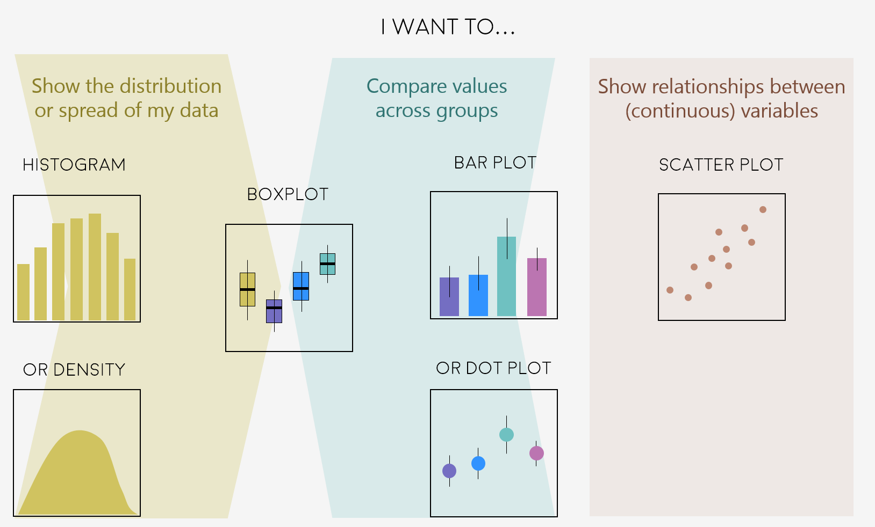
Figure 1: Types of plots divided by the intention of the author. Left panel: types of plots to show data distributions. Middle panel: plots used for comparisons. Right panel: plots to show relationships.The captions should briefly describe what is in the figure so the reader can understand what is in it. This image has been taken from Coding Club. Because this image is under a CC BY-SA license I can use it here giving the proper attribution to the creators. This image can be found at https://ourcodingclub.github.io/tutorials/datavis/.

Guidelines for tables
Tables must be inserted in editable format. Table titles should be placed immediately before the table starting with "Table X", for example, "Table 1". Use only one paragraph for the title. The acronyms used in the tables must be defined in a lower cell.
 |  | Normal-hearing listeners | Hearing-impaired listeners
Outcome from the easy test (unit) | Left | 50.00 | 25.30
 | Right | 50.50 | 24.80
Outcome from the difficult test (unit) | Left | 42.50 | 5.20
 | Right | 43.88 | 5.20

Table 1: Table of a typical presentation of some results. When using tables with numerical results, please, use always the same number of significant values (digits after the dot ) and align to the right. The unit can better be written with the description of the outcome.
Large tables that cover multiple pages cannot be included in the final publication view for formatting reasons. These tables will be published as supplementary material.

Main text
The text must have double leading and 12 font size points. Italics should be used instead of underlined. Figures, illustrations, and tables should be placed in the appropriate text places (typically where they are first referenced) and not at the end. The document must contain page and line numbers to facilitate the review process. Research studies should include in the main text:

Introduction
Cannot be divided into subsections.

Materials and methods
This section can be divided into subsections and should be sufficiently detailed to guarantee that procedures can be replicated. Studies with animals or humans should include an ethical approval statement in this section (for more information, see the ethics section in the journal policies). If the method is contains an step by step procedure, this can be written as a ListNum:
- Data curation: the data is divided into different…
- Data processing: the data was then transform using…
- Data analysis: a principal component analysis…

Results
This section can be divided into subsections. Footnotes can be used, although their use should be minimized.

Discussion
It can be divided into subsections. This section may include, for example, comparison with previous studies, deficiencies and potential limitations of the study, future direction of research, etc.

Conclusions
The most relevant findings of the study should be briefly summarized.

References
References will be identified in the text according to the standards of the American Psychological Association (APA)
(https://apastyle.apa.org/style-grammar-guidelines/references).
The list of references should only include articles that are published or accepted. Accepted but unpublished manuscripts should be described as "in press". References to data repositories or computer code are allowed. The version and unique identifier should be included when available. It is not recommended to cite master's thesis or doctoral theses as well as lecture articles if there was an article published in a scientific journal with similar content.
References to articles deposited on preprint servers (pre-prints) are allowed as long as there is a DOI or URL available and the quote clearly mentions that the contribution is a pre-print. If there is a peer-reviewed publication for pre-printing, then the publication of the official journal should be cited. The use of pre-impressions that have not been updated in the last year is discouraged as it suggests that the study is not being considered for publication in a scientific journal.
The DOI of the study cited should be provided whenever available.

References
This is an example of APA style
Békésy, G. V. (1947). The Variation of Phase Along the Basilar Membrane with Sinusoidal Vibrations. J. Acoust. Soc. Am., 19, 452-460.https://doi.org/10.1037/ppm0000185
Kemp, D.T. (1978). Stimulated acoustic emissions from within the human auditory system. J. Acoust. Soc. Am. 64, 1386-1391. https://doi.org/10.1121/1.382104
Davis, P.A. (1939). Effects of acoustic stimuli on the waking human brain. J. Neurophysiol. 2, 494-499. https://doi.org/10.1152/jn.1939.2.6.494
Mdpi nanomaterials. Word Template. Available at: https://www.mdpi.com/files/word-templates/nanomaterials-template.dot

Appendix A
In case of more than one appendix, this would use letters.

At the end of the manuscript, the following parts are obligatory to be added, the text below is based on the reference 4:
Conflict of interest
Declare conflicts of interest or state “The authors declare no conflict of interest.”. All financial, commercial or other relations that may be perceived as representing a possible conflict of interest should be mentioned. If no such relationship exists, the authors shall declare that the investigation was conducted in the absence of commercial or financial relations that could be interpreted as a possible conflict of interest.
Funding:
Please add: “This research received no external funding” or “This research was funded by NAME OF FUNDER, grant number XXX” and “The APC was funded by XXX”. Check carefully that the details given are accurate and use the standard spelling of funding agency names at https://search.crossref.org/funding. Any errors may affect your future funding.
Data Availability Statement:
In this section, please provide details regarding where data supporting reported results can be found, including links to publicly archived datasets analyzed or generated during the study.
At the end of the manuscript, the following parts are not obligatory to be added:
Acknowledgements
This section should recognize the contributions of collaborators, institutions or agencies that contributed to the development of the study.
Complementary material
Data and elements that are not of paramount importance or that cannot be included in the article for extension reasons (videos, PowerPoint presentations, etc.) may be presented as supplementary material. The supplementary material will be displayed along with the published article.

