***Supplementary Material 1***

**A multimodal database for the collection of interdisciplinary audiological research data**

**M. Amparo Callejón-Leblic1, 2, *, Sergio Blanco-Trejo1, Brenda Villarreal-Garza1, Ana M. Picazo-Reina1, Beatriz Tena-García1, Ana Lara-Delgado1, Manuel Lazo-Maestre1, Francisco López-Benitez1, Fernando Escobar-Reyero1, Marta Álvarez-Cendrero1, M. Luisa Calero-Ramos1, Cayetana López-Ladrón1, Cristina Alonso-González1, Francisco Ropero-Romero1, Leyre Andrés-Ustarroz1, Marta Cuaresma-Giráldez3, Mercedes Atienza-Ruiz4, 5, J. L. Cantero-Lorente4, 5, Alberto Moreno-Conde3, Jesús Moreno-Conde3, Serafín Sánchez-Gómez1**

*1 Otolaryngology Department, Virgen Macarena University Hospital, Seville, Spain*

*2 Biomedical Engineering Group, University of Seville, Seville, Spain*

*3 Innovation Unit, Virgen Macarena University Hospital, Seville, Spain*

*4 Laboratory of Functional Neuroscience, Pablo de Olavide University, Seville, Spain*

*5 Neurodegenerative Diseases Network Research Center (CIBERNED), Madrid, Spain*

**\*Correspondence:** Corresponding author: [mcallejon@us.es](mailto:mcallejon@us.es)

This supplementary material includes visualization of data that are not reported in the main body of the paper. The supplementary material visualizes captures of the database and the main sections.

S1_Figure 1 shows some captures of the main database registration module:

1. Panel A shows a caption of the portal of the database platform. Users are requested to input their access credentials in order to log into the digital platform. In order to use the demo version, the reader must use the following information:
   1. Link: <https://plataforma.innovacionsalud.org/auth/misiones_a1/login>
   2. User: demo_misiones
   3. Password: 123456
2. Panel B shows a caption view of the baseline clinical and demographic data section, specifically, that showing the comorbidities section, such as cardiovascular diseases, previous history of cancer, sleep disorders, etc.
3. Panel C shows the Hearing Loss section, where a more specific description of the disease is provided.
4. Panel D shows the Audiometry and Speech Test Section.

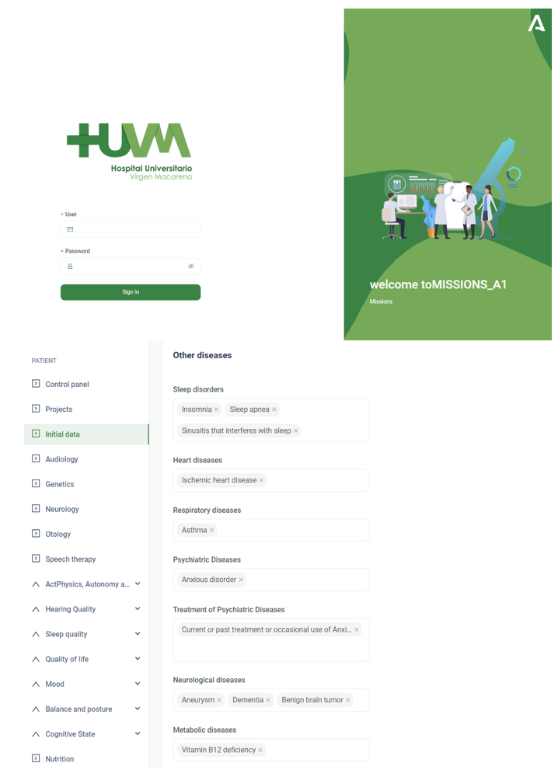

A.

B.

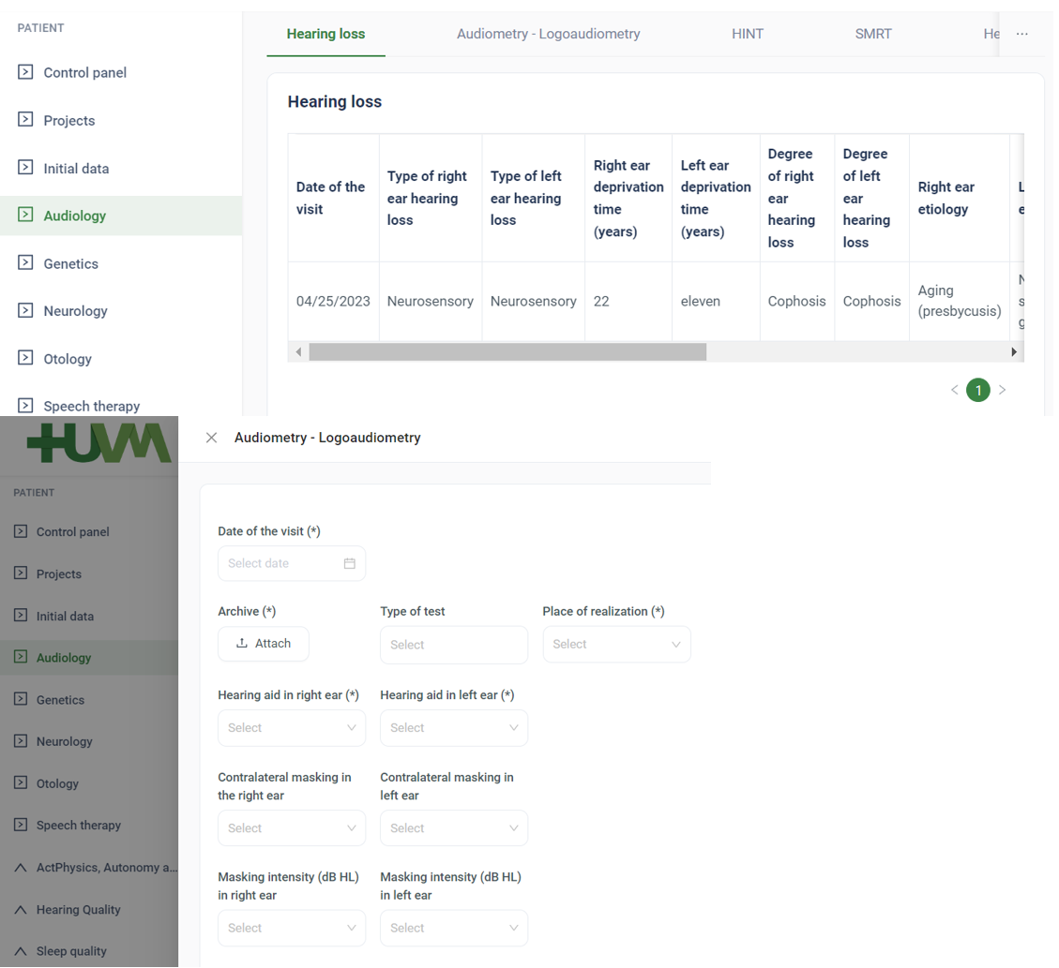

C.

D.

S1_Fig1. Main database registration module. A Portal to the digital platform implemented. B Baseline clinical and sociodemographic section. C Hearing loss section. D Audiometry and speech test section.